**Object Oriented Programming**

**Lab Report**

**Lab01**



|  |  |
| --- | --- |
| Group Members Name & Reg #: | **Muhammad Haris Irfan**  **(FA18-BCE-090)** |
|  |  |
| Class | Object Oriented Programming CSC241 (**BCE-4B**) |
| Instructor’s Name | Maam Amber Madeeha Zeb |

**In Lab Tasks**

**5.1 Task 1:**

**Write a program that declares a structure to store book Id, price and pages of a book. The structure should include functions to assign user defined values to each book and display the record of most costly book.**

**Solution:**The code is given below,

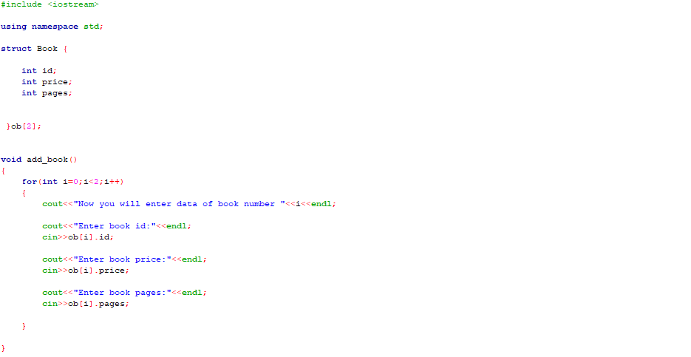

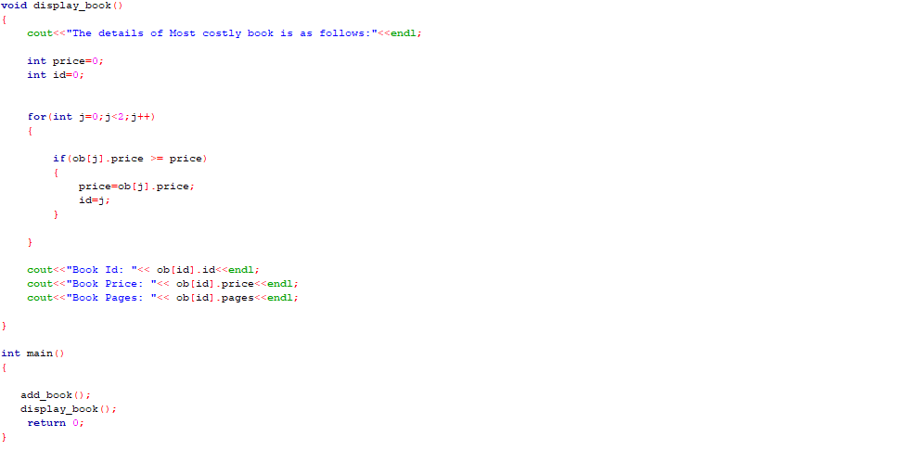

Console Output solution is shown below.

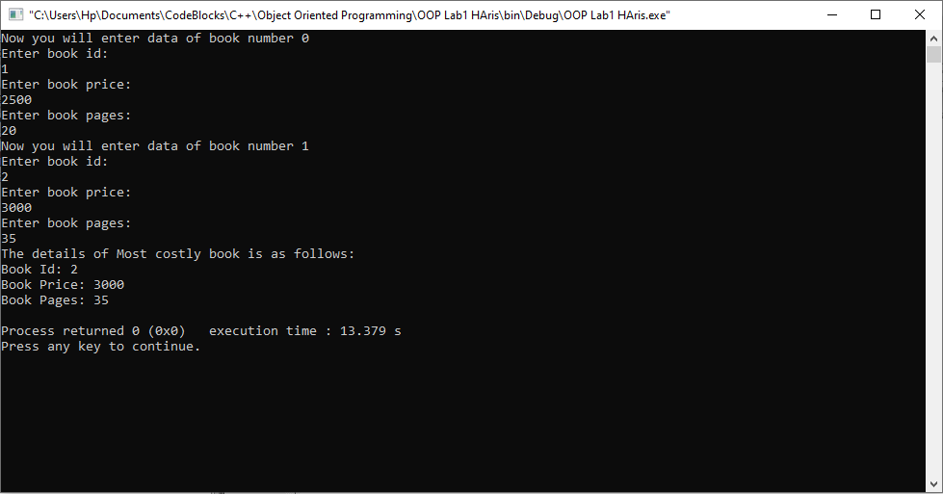

____________________________

**5.2 Task:2**

**Write a program to take the values of two integers and use pointers to add 10 to the value of each integer.**

Solution:

I am attaching my code below,

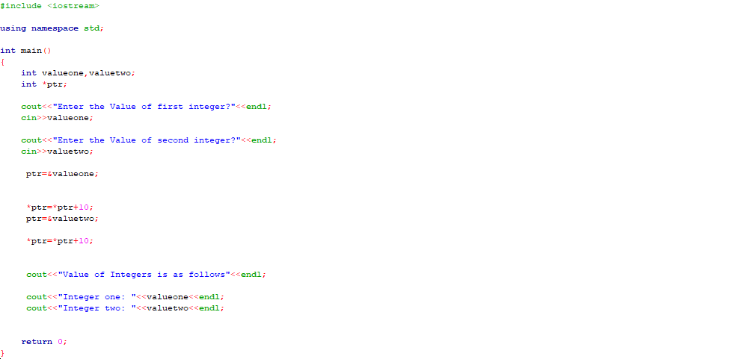

The result for this program is shown below,

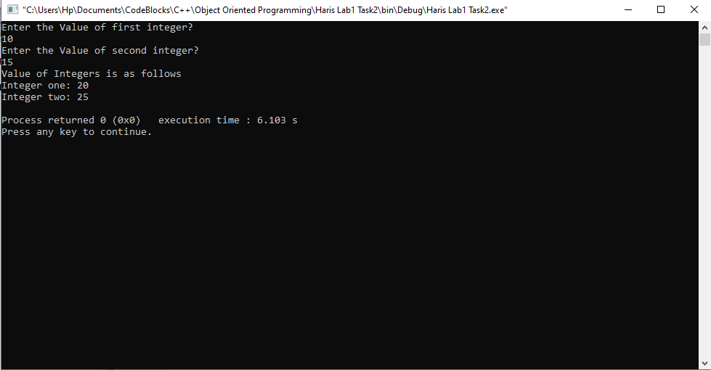

_____________________________

**5.3 Task:3**

**Write a function that swaps the values of two integer variables**

Solution:

I am attaching my code below,

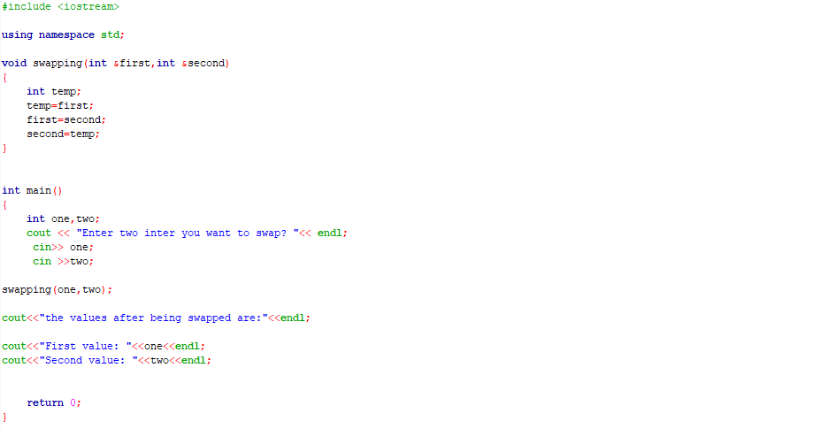

The result for this program is shown below,

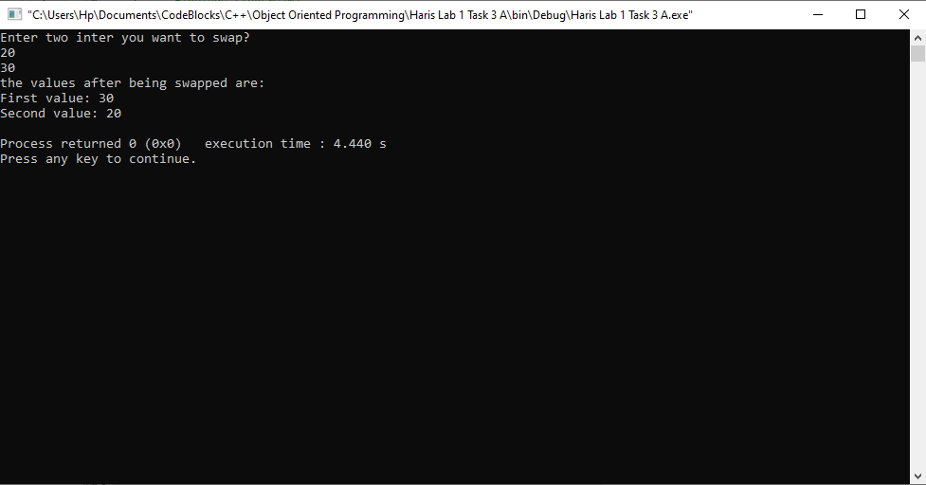

The above sorting is done by passing reference, whereas with value you cannot change the actual value.

_____________________________

POST LAB

6.1 Question 1:

**There is a structure called employee that holds information like employee code, name, date of joining. Write a program to create an array of the structure and enter some data into it. Then ask the user to enter current date. Display the names of those employees whose tenure is 3 or more than 3 years according to the given current date.**

Solution:

I am attaching my code below,

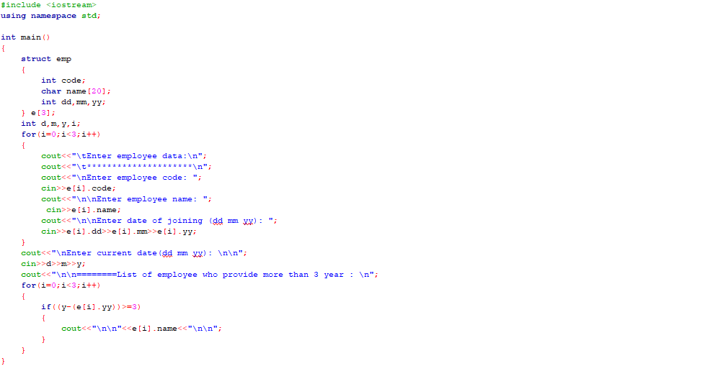

The result for this program is shown below,

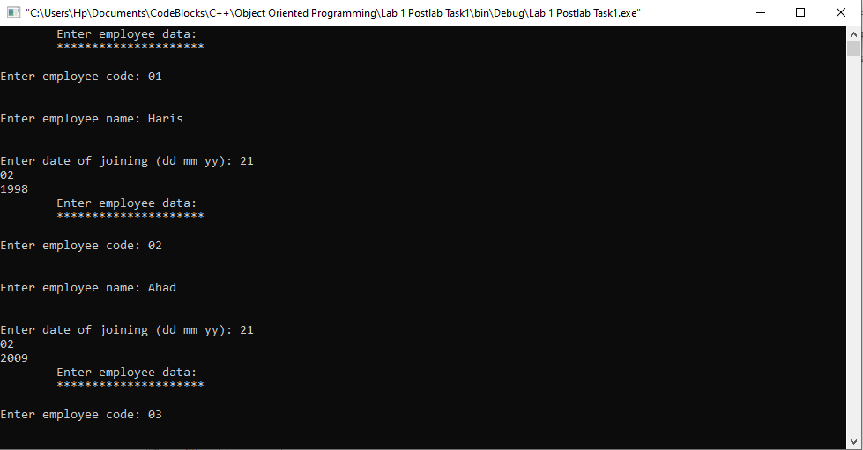

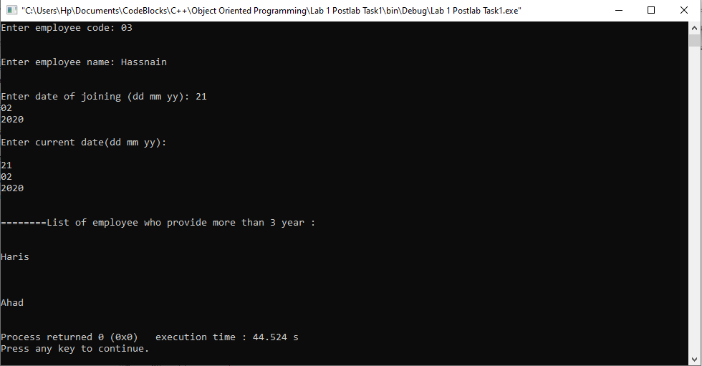

_______________

6.2 Question 2:

**Write a function to sort data (in increasing order) in an array.**

Solution:

I am attaching my code below,

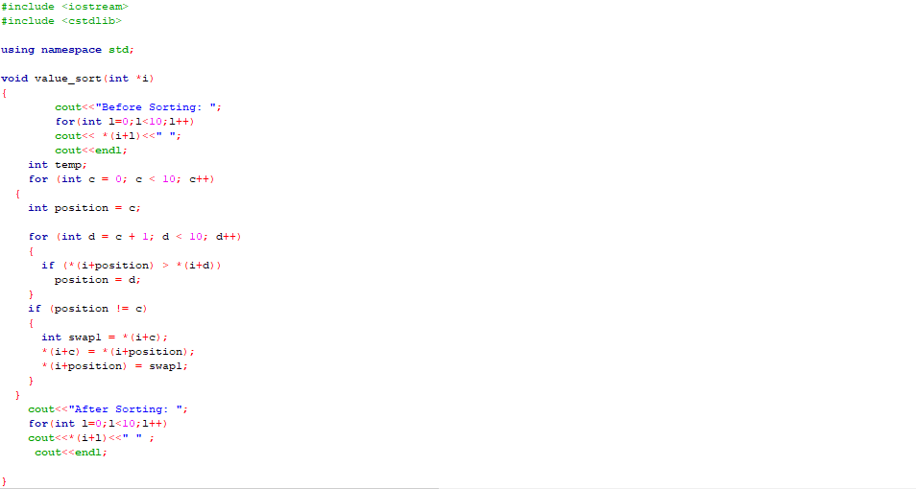

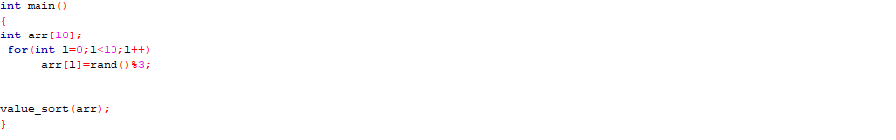

The result for this program is shown below,

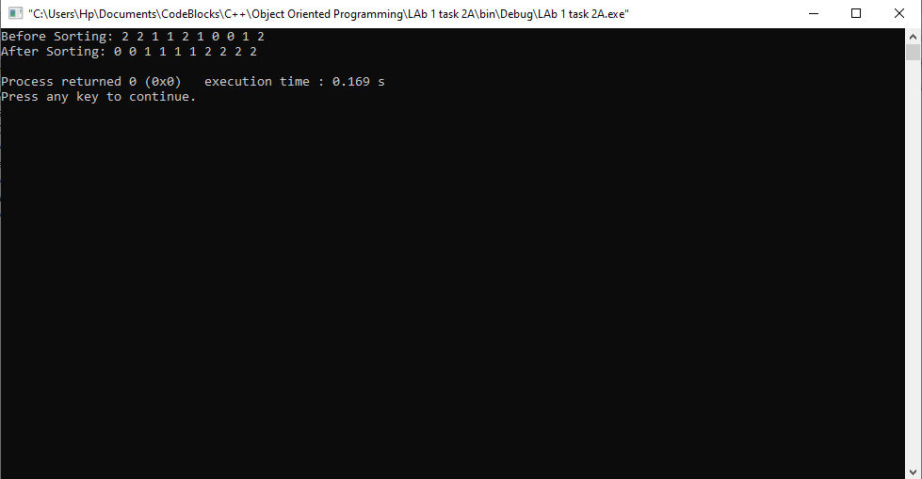

The above sorting is done by passing reference, because you cannot pass an array by value.

_______________

6.3 Question 3:

**Write a program that inputs a string value from the user and displays it in reverse using pointer.**

Solution:

I am attaching my code below,

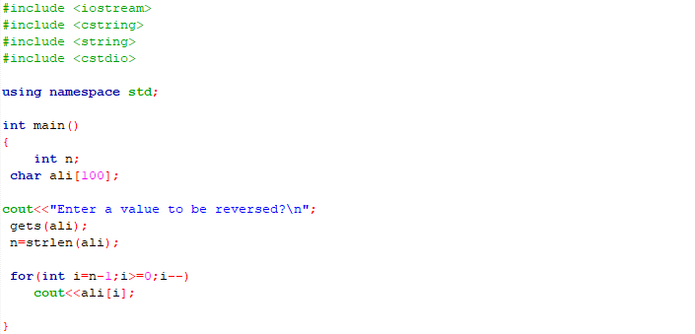

The result for this program is shown below,

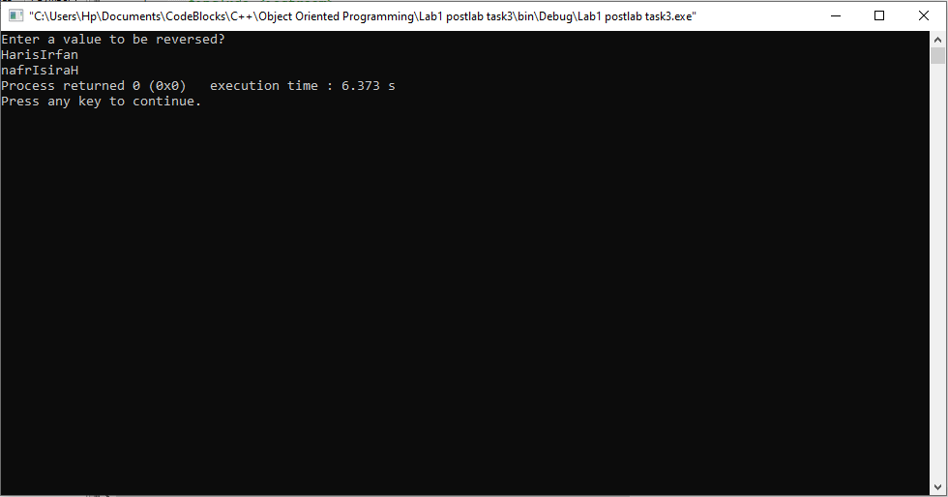

______THE END________

_______________